Learn about Women in Resistance in Guatemala
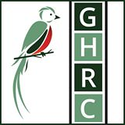
OSU Delegation to Guatemala
August 29-September 6, 2015
Application Deadline: March 5

Women in Guatemala are organizing to defend their rights. They are combating violence and destructive large-scale development projects that have a negative impact in their lives by destroying their habitat and poisoning their fields, food, and water. They are also demanding justice for genocide and other crimes, and as a result they have been victims of repression and criminalization.

We have the opportunity this summer to meet some of these amazing women. Led by the Guatemalan Human Rights Commission, an advocacy organization with a base both in Washington and Guatemala, the delegation will visit several organizations in Guatemala City and the countryside. We will meet with community organizers, activists, and victims’ advocates.

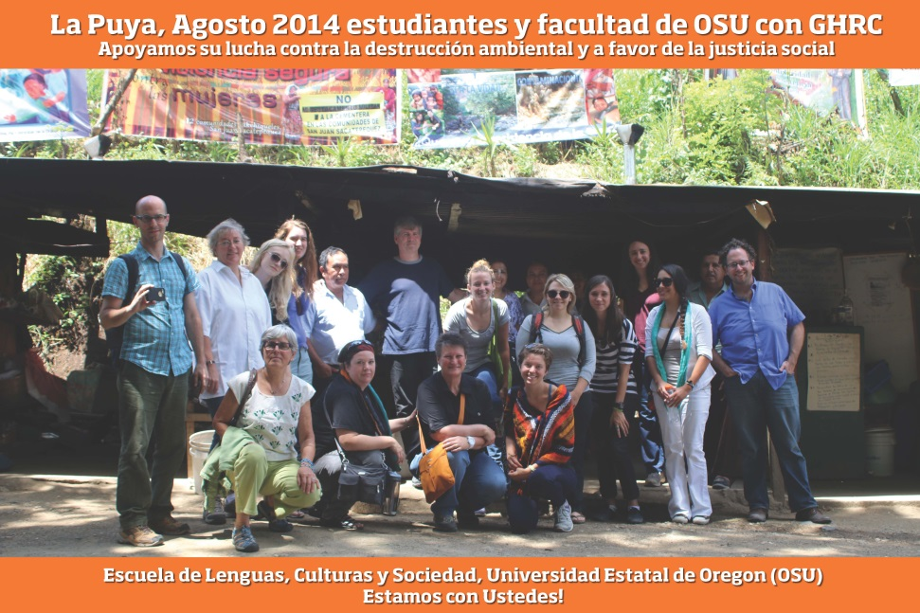

Examples of the organizations we may visit include:

- UNAMG (National Union of Guatemalan Women) is a feminist organization dedicated to social, political, and cultural transformation. Founded on March 8, 1980, UNAMG was forced to work in exile for several years as a result of extreme political oppression. UNAMG currently focuses on investigations and publications that document violence against women and women's participation in civil society. They also run empowerment and healing programs for women who were victims of violence during the internal armed conflict, In 2010 the organization helped organize the "Tribunal de Conciencia,” a mock trial in which women who suffered sexual violence during the war shared their testimonies.

- UDEFEGUA (The Human Rights Defenders Protection Unit) responds to threats and attacks against human rights defenders in Guatemala. They investigate incidents of violence against defenders, accompany the men and women who have received threats, and provide security workshops for individuals, communities and organizations at risk. UDEFEGUA is a member of the Human Rights Convergence, a coalition of Guatemalan organizations that promote policies and practices that protect human rights defenders.

- CALDH (Center for Human Rights Legal Action) fights for truth and justice on behalf of victims of genocide in Guatemala. The organization provides legal counsel with the goals of promoting the recovery of historic memory, combating impunity, dismantling of racist and oppressive structures, and defending human rights. CALDH's legal team has promoted a number of emblematic human rights cases before national and interactional courts. Along the "Plan de Sánchez" massacre case, they have successfully co-prosecuted General Efraín Ríos Montt for genocide and crimes against humanity.

- ASOGEN (Association of Women Generating Equality, Leadership and Opportunities) is a women-led nonprofit based in Chimaltenango which provides comprehensive services to women survivors of domestic violence, including legal advice, counseling, monitoring of legal cases, and access to shelters. ASOGEN promotes the rights of women, including sexual and reproductive rights, as well as citizen participation, holistic development and leadership. ASOGEN also advocates with the Guatemalan government to implement the law against femicide.

- La Red de Mujeres Ixiles (Association of Ixil Women) is an organization based in Nebaj that supports female victims of violence and works to empower women in the region. The organization's legal aid office provides Ixil women with guidance, accompaniment, counseling, and legal assistance. Juana Baca Velasco, the coordinator, has been repeatedly threatened and intimidated for her work in the defense of human rights.

- Casa Artesana (Artisan House) was founded in 2006 by Andrea Barrios and Sandra Moran as an artistic space for developing creative solutions to support women who have suffered discrimination and violence. The organization also works with imprisoned women, using art therapy to educate them about their rights, promote self-esteem, and to provide a creative outlet for expression. Casa Artesana works to restore the sense of self and dignity of these women, while also striving to maintain their family unity.

Delegation cost will be around $1250, which includes room, board, and transportation inside Guatemala. Flight cost from Oregon is around $1000. A $200 nonrefundable deposit is due April 1.

Program is available for 1-3 credits (undergraduate or graduate), but students are not required to take credits. OSU faculty and staff are welcome to join the delegation. Course credits are available through: Anthropology, Ethnic Studies, Women, Gender and Sexuality Studies, World Languages and Cultures. Financial Aid may apply if a student wants to receive credit.

Deadline is March 5. We will contact you for an interview after receiving your application.

For more information contact:
Susan Shaw, sshaw@oregonstate.edu
Anuncia Escala, Aescala@oregonstate.edu

Spots are limited. We will accept applications on a first come basis
Deadline: March 5, 2015

Sponsored by the School of Language, Culture, and Society
& The Guatemalan Human Rights Commission (GHRC)
a non-profit, grassroots, solidarity organization dedicated to promoting human rights

For information on the Guatemala Human Rights Commission, http://www.ghrc-usa.org

