OSU Master Gardeners™ Educate and Serve Oregonians. Master Gardeners™:

- Provide non-biased, science-based gar- dening information to the public
- Diagnose plant problems and provide sustainable solutions to Oregon gar- deners
- Design and present education programs on subjects of interest to Oregonians including
- Integrated pest management (IPM) practices
- Yard waste management and composting
- Water quality protection
- Gardening with children, youth, sen- iors and the physically challenged
- Provide a window to research and edu- cation at Oregon State University to Oregonians.

The Oregon Master Gardener™ Association (OMGA) serves four main functions as part of the Oregon Master Gardener Program:
- To enhance and supplement the Oregon State University Home Horticulture Program
- To assume responsibility for performing spe- cial tasks and engaging in continuous activities related to the program
- To promote a wide dissemination of infor- mation available as a result of University study and experimentation. Such information shall be in accordance with Oregon State University standards
- To work with other gardening organizations to enhance gardening in Oregon, when appropri- ate.

Th e
Karl Carlson Memorial
Fund

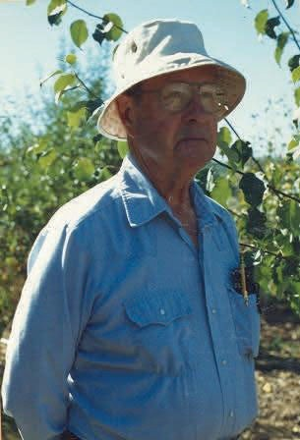

Offered By

Oregon Master GardenerTM Association in cooperation with OSU Extension Service

Lifetim e of Achievement Memorial

The Karl Carlson Memorial Fund com- memorates the life and work of Dr. Karl Carlson.
Karl Carlson was born on July 9, 1918 in Ishpeming, Michigan. He attended schools in Connecticut and was an ex- change student in Germany for one year prior to the beginning of World War II.
Karl met his wife, Mary, while both at- tended Stanford University. He received his Doctor of Medicine Degree from Stan- ford and served two years as a Captain in the United States Army Medical Corps and in the United States Air Force.
Following military service, Karl received his medical specialty training in Rehabili- tation Medicine at New York University and at the Bellevue Medical Center in New York City. He founded the Depart- ment of Rehabilitation Medicine at Palo Alto with a Stanford Medical School fac- ulty rank of Assistant Professor of Medi- cine.
Two years before his retirement in 1979, Karl transferred to the V.A. Medical Center in Rose- burg, Oregon, where he was chief of the Reha- bilitation Medical Service. Dr. Carlson retired from practice in 1981 but remained active as a diplomat of the American Board of Physical Medicine and Rehabilitation.
Retirement allowed Dr. Carlson a chance to literally, 'smell the roses'. In his home garden, however, Karl particularly loved to grow vege- tables.

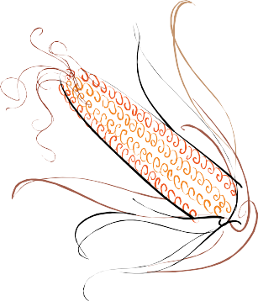

Karl Carlson was a charter member of the Douglas County Chapter of the OSU Master Gardener Association. Karl organized the first Master Gardener classes in Douglas County and was the motivating force in keeping that chap- ter’s OSU Master Gardener information office open during the year prior to the hiring of an Urban Horticulture Agent.
Karl served as the very first President of the Douglas County Chapter of the OSU Oregon
Master Gardener Association. He was elected as President of the Oregon Master Gardener Association in 1989. That year, Karl presided over the Second Interna- tional Conference of Master Gardeners in Portland, Oregon. Nearly all states were represented as well as several foreign countries.
Cancer claimed the life of Dr. Karl Carl-
son on April 10, 1992 in Roseburg, Ore- gon.

Dr. Karl Carlson is remembered by many
as “a sweet, cheerful and extremely intel- ligent man” and one who sincerely loved
his work as an OSU Master Gardener, both at local and state levels.

The Karl Carlson Memorial Fund is Dr.
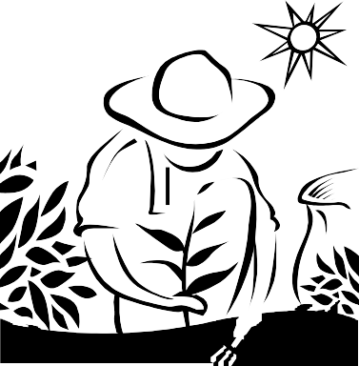
Carlson’s legacy, a tribute to his dedica- tion to the Oregon Master Gardener Asso- ciation and to the Oregon State University

