

American Chemical Society

PORTLAND SECTION

Dear Chair,

We are writing on behalf of the American Chemical Society (ACS) Portland Section, to inform you about the Oregon Science Startup Forum, which we are presenting Saturday, April 28, 2018 at the Learning Innovation Center at Oregon State University in Corvallis. This conference is conceived as a how-to manual for people interested in starting a science-oriented business in Oregon.

We have more than 18 high-profile speakers lined up, including Skip Rung, the executive director of the Oregon Nanoscience and Microtechnologies Institute, and Mark Lieberman, Chief Startup Officer at OSU and Director of the OSU Advantage Accelerator. Attendees will hear about the experiences of science entrepreneurs from around Oregon and interact with experts in turning scientific ideas into businesses, and how to present those businesses to investors. For a complete description, please see our website at <https://bit.ly/OSSFwebsite>.

We are writing to ask you help us publicize this to your students and faculty. With two tracks, the Forum should be appropriate to anyone from undergraduates with visions of starting a company in the future to faculty with patents and maybe a company of their own. We would appreciate your forwarding this email to your students and colleagues, and posting the attached poster in several conspicuous places in your department.

Thank you for your help. Please do not hesitate to contact us with questions.

Best regards,



Jim Tung, OSSF Chair, Portland ACS Section

jimtung@gmail.com, (574) 621-4926

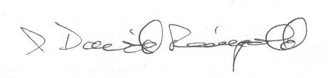

I. David Reingold, Treasurer, Portland ACS Section

[reingold@juniata.edu](mailto:reingold@juniata.edu), 814-386-2264