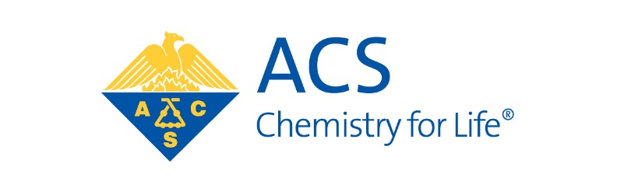
American Chemical Society
PORTLAND SECTION

Calling all undergrads who did research in chemistry (or a related field) over the summer, at an institution, at a company, a national lab, wherever...

Join the Portland ACS section
for the fourth annual
FALL UNDERGRADUATE
POSTER SYMPOSIUM & CAREER FAIR

Sunday, Oct. 22 from 4-7 PM

Entrance foyer
Science Research & Training Center (SRTC)
Portland State University
SW 10th & Montgomery St.

Deadline for submission October 11

• $150 prize for best in each of seven divisions!
• $75 second place prizes may be awarded
• pizza, pastries, networking, and CHEMISTRY!
• visit with local industry sponsors and graduate schools!

https://sites.google.com/site/portlandacsposters/home

Questions? Email Dave Reingold: reingold@juniata.edu

