Road Map and Timeline to Success

Think about your goals for the future. Write these goals along the road, creating your road map.

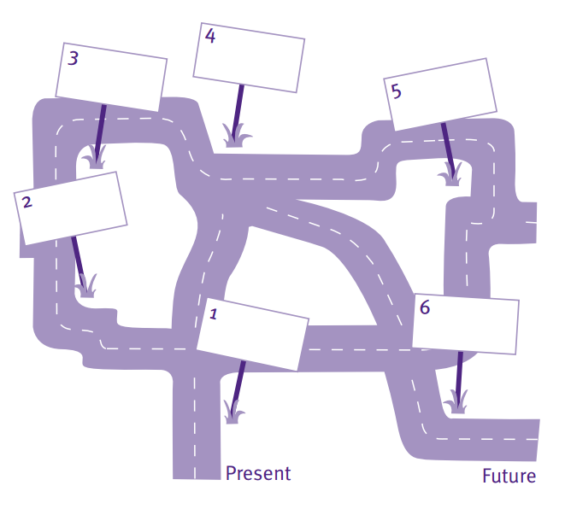

Now that you have created your road map with your main goals, think about the steps you need to take to reach those goals. We’re going to focus on what you can do within the next year to head in the right direction. Fill out the timeline with ideas you have for what you can do to accomplish your goals.

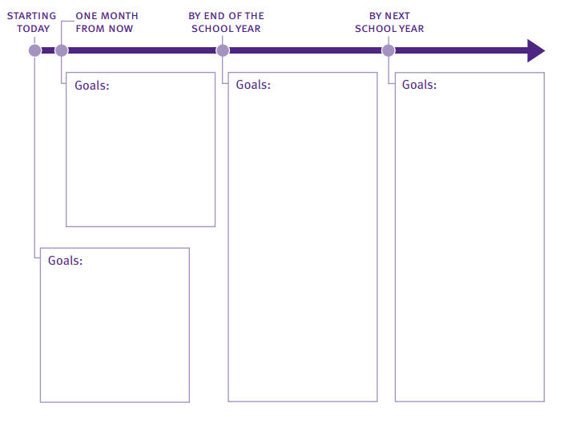

Reaching Your Goals

With a partner or small group, take a few minutes to discuss the goals you came up with. Use the following questions to guide your discussion:

Questions for you to answer:

1. What goal do you hope to achieve by next school year?
___________________________________________________________________________________________________________________________________________________________________________________________________________________________________________________________________________________________________________________________________________________________________________
2. Why did you choose this goal?
___________________________________________________________________________________________________________________________________________________________________________________________________________________________________________________________________________________________________________________________________________________________________________
Questions for you and your partner to answer together:
3. What will it take for you to achieve this goal?
___________________________________________________________________________________________________________________________________________________________________________________________________________________________________________________________________________________________________________________________________________________________________________
4. How can your family and friends help you accomplish this goal?
___________________________________________________________________________________________________________________________________________________________________________________________________________________________________________________________________________________________________________________________________________________________________________

