Lesson 7

Preparing for High School: Coach Guide

Learning Goals
- Students will know how high school differs from middle school.
- Students will address their concerns for high school with their coach.
- Students will be able to understand and apply effective study habits.

Introduction (~5 minutes)
- Briefly introduce the lesson
  - Welcome students back to Beaver Hangouts! Let them know that this lesson will focus on preparation for high school and building good study habits.
  - Give the students a short background on your high school experience and ask if they have any questions before the lesson starts.
    - Did you enjoy high school? How did you change over the four years of high school? Do you still remember your first day of freshman year?

Think, Pair, Share! (~5 minutes)
- Why is high school so scary?
  - Give student a few minutes to brainstorm and write down their thoughts about high school. Ask them, “What are some things that frighten you about high school?” This will allow you to gauge the students’ expectations for their freshman year, which will help you teach this lesson more effectively. Have students share their answers to begin the discussion and address each students’ response either with advice or stories from your own experience.

Activity 1 (~15 minutes)
- Middle School vs. High School
  - On the schedule template worksheet, have students fill out what a typical day looks like for them.
  - Then, ask the students to compare their day to the example high school student’s day in this video: https://www.youtube.com/watch?v=wUBr64fpm0U
  - To start the discussion, as the students to think: in what ways are their days as middle schoolers different from the high schooler’s? In what ways are they similar?
    - Some students may have schedules that look similar to the high schooler’s day. Challenge them by asking them to imagine how their days would be different, even if the schedules are similar.

Activity 2 (~15 minutes)
- Being Academically Successful in High School
  - There are many aspects that make up the full high school experience – friends, college planning, relationships, sports, music, etc. With everything going on, it’s crucial to stay on top of one of the most important aspects: academics.
  - In high school, students have to be more proactive than they were in middle school. This activity will help them figure out habits they can adopt to help them be successful students. Have the students fill out the diagram to the best of their abilities.
  - Go over the diagram with the students and either ask or give examples for each technique.
    - For example, “I have a big history exam coming up next Friday. How should I prepare for this using the techniques we know?”
  - Ask the students if they have any questions on the activity.

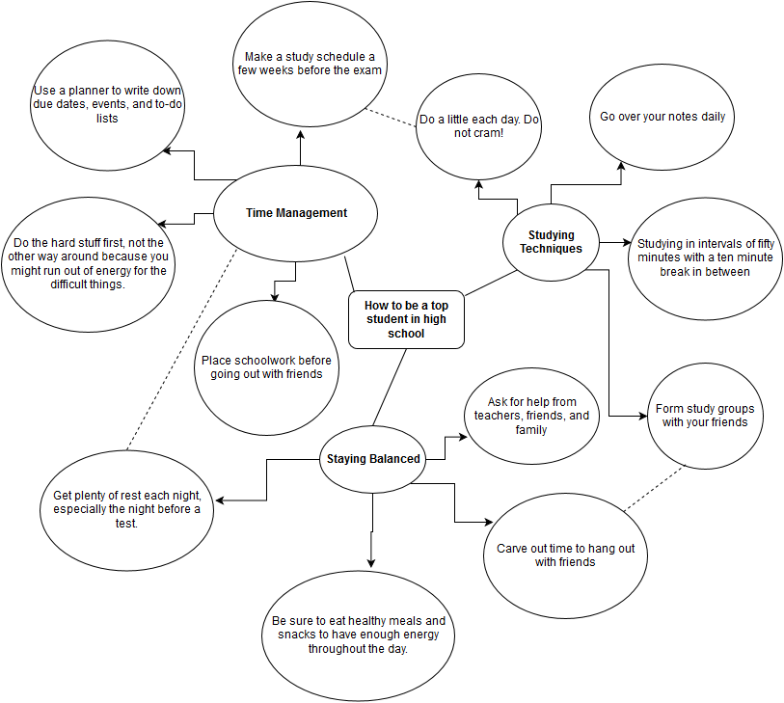

Closing/Assignment (~10 minutes)
- Wrap-up & Q&A Session
  - Students may have a lot of questions regarding high school, so leave some time to answer their questions.
  - Optional: Give students a short assignment for next time

Lesson 7

Preparing for High School: Student Worksheet

Think, Pair, Share!
Get in groups of 2 or 3 with the classmates sitting next to you. Brainstorm what you’re afraid of or excited about for high school!

Activity 1: Middle School vs. High School

Similarities:

Differences:

Activity 2: Being Academically Successful in High School
Word Bank:
- Use a planner to write down due dates, events, and to-do lists
- Get plenty of rest each night, especially the night before a test
- Place schoolwork before going out with friends
- Ask for help from teachers, friends, and family
- Do a little each day. Do not cram!
- Carve out time to hang out with friends
- Studying in intervals of fifty minutes with a ten minute break in between
- Be sure to eat healthy meals and snacks to have enough energy throughout the day.
- Go over your notes daily
- Do the hard stuff first, not the other way around because you might run out of energy for the difficult things.
- Form study groups with your friends
- Make a study schedule a few weeks before the exam

